Machine Translation

Source: https://people.ischool.berkeley.edu/~dbamman/nlp20_slides/24_MT.pdf

- Learned from parallel text aligned at the sentence level
- Evaluation
  - BLEU: what fraction of n-grams appear in system and reference translations where
  - Optimize score by minimizing number of generated n-grams using a brevity penalty where c is the length of the system translation and r of the reference translation
- Datasets: Europarl, MultiUN

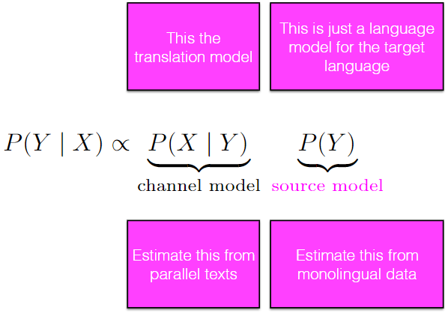
Statistical machine translation
- Noisy channel model
- Alignments at the sentence level, not word level
- Attention changes with each word generated during decoding
- Better performance on long sentences

